Amos Mobile - Installation

1 Foreword 2

2 Setting up the scanner 2

2.1 Windows XP 2

2.1.1 Connecting scanner 2

2.1.2 Copying over the amos mobile installation file 4

2.2 Windows 7 5

2.2.1 Connecting scanner 5

2.2.2 Copying over the amos mobile installation file 7

3 Installation on mobile device 8

Thomas Schoof

18/06/2015

# Foreword

This guide is created with the intention of setting up the scanner on the PC where the synchronisation will happen.

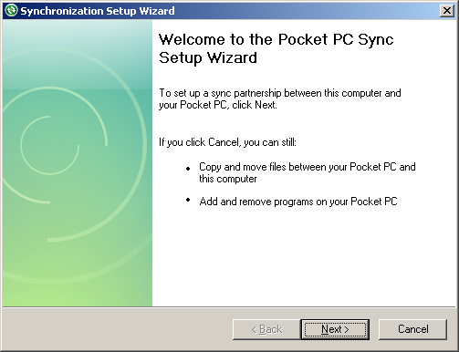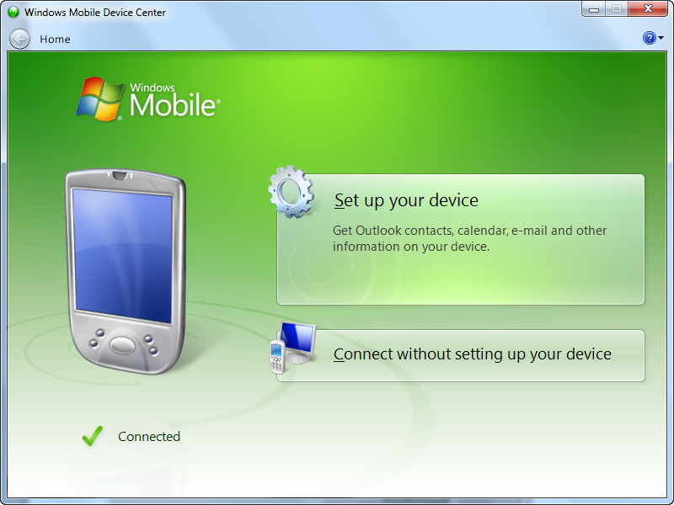If this isn’t the case, you don’t need to do the set-up of ActiveSync/Windows Mobile Device Center. You can just “Cancel”/”Connect without setting up your device” and continue to copy the installation file.

# Setting up the scanner

## Windows XP

### Connecting scanner

* Plug in the cradle to the computer
* Put the scanner in the cradle
* Now there are 3 possibilities

#### Nothing happens (no active sync)

* Install ActiveSync 4.5 (Next next... finish)
* Remove and put the scanner back in the cradle
* Continue to 1.1.1.2

#### ActiveSync not set up

If you get one of these 2 windows, it means active sync is not set up.

* Click on “OK”  
   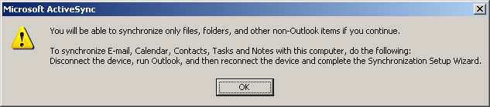
* Click on “Next”  
  
* Fill in a name and click on “Next”
* **Uncheck** everything and click on “Next”  
  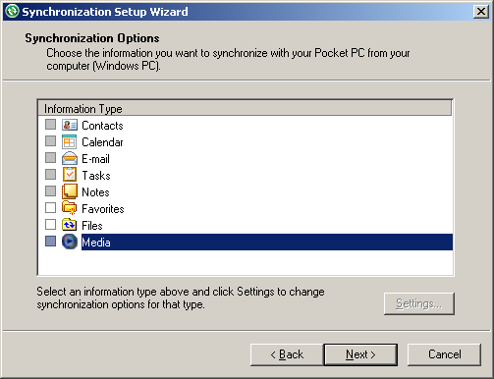
* Click on “Next”
* Click on “Finish
* Continue to 1.1.2

#### ActiveSync set up

If you get this window it means ActiveSync has been correctly set up. Continue to 1.1.2.

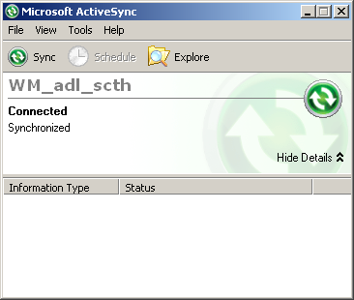

### Copying over the amos mobile installation file

* On the ActiveSync window click on “Explore”
* Double click on “My Windows Mobile-Based Device”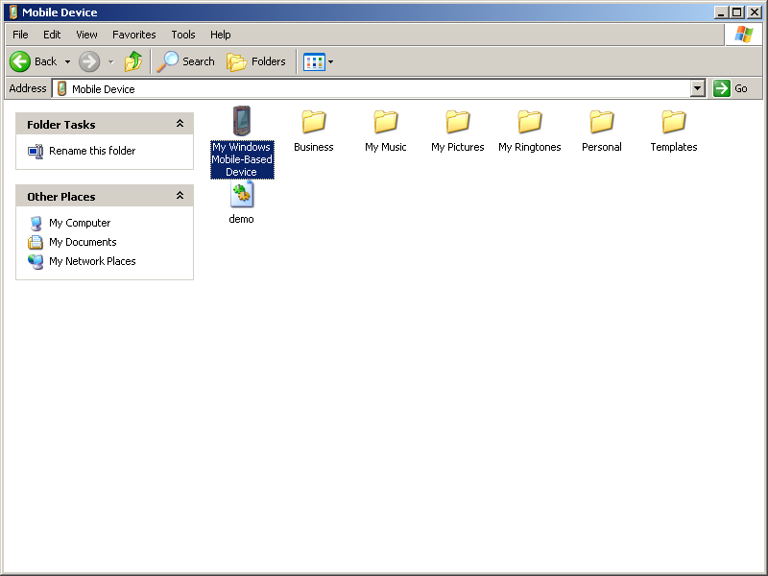
* Double click on “Storage Card”
* Double click on “Install”
* There should be 4 files there already.
  + Remove all files
* Copy over the new Amos Mobile installer files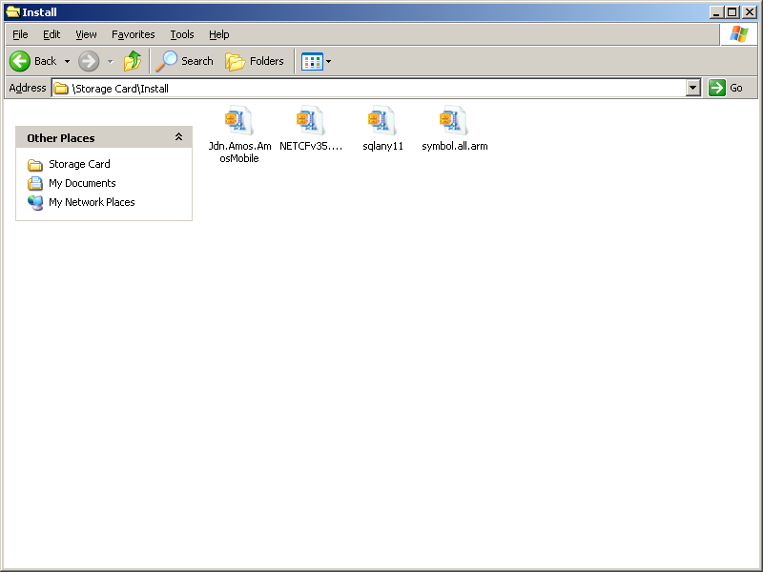

## Windows 7

### Connecting scanner

* Plug in the cradle to the computer
* Put the scanner in the cradle
* Now there are 3 possibilities

#### Nothing happens (Windows Mobile Device Center not installed)

If nothing happens when you insert the cradle, this usually means Windows Mobile Device Center is not installed.

* Check if the program isn’t installed
* Contact ICT-Servicedesk to install Windows Mobile Device Center
* Remove and put the scanner back in the cradle
* Continue to 1.2.1

#### Windows Mobile Device Center not set up

If you get the following screen it means Windows Mobile Center has not been set up yet.

* Click on “Set up your device”
* **Uncheck** everything and click on “Next”
* Enter the device name and press “Set Up”
* Continue to 1.2.2

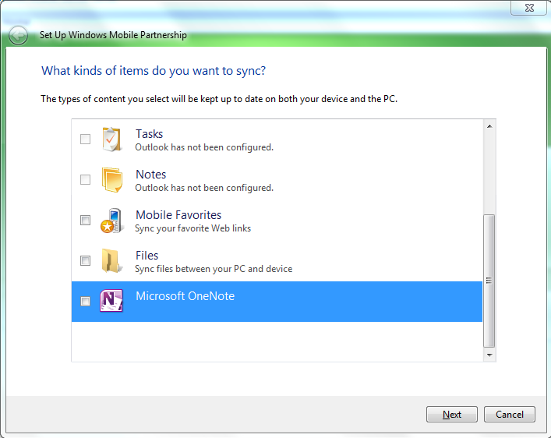

#### Windows Mobile Device Center already set up

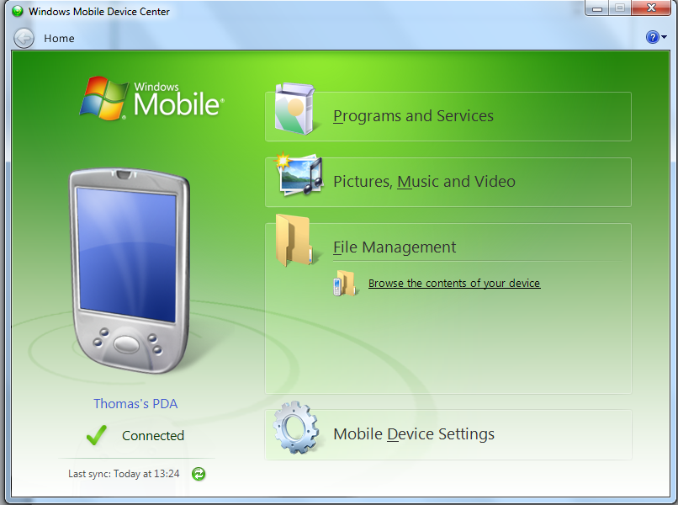If you get this window it means Windows Mobile Device Center has already been set up correctly.

Continue to 1.2.2.

### Copying over the amos mobile installation file

* In the windows mobile device center click on “File Management, Browse the contents of your device”
* Double Click on “Storage Card”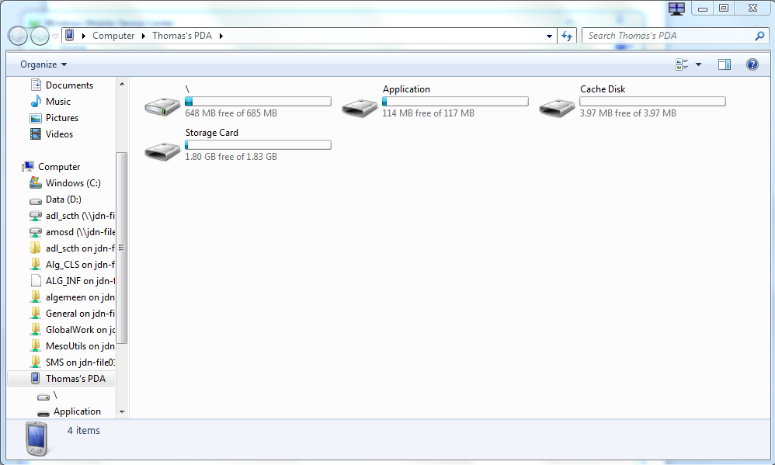
* Double click on “Install”
* There should be 4 files there already.
  + Remove all files
* Copy over the new Amos Mobile installer files 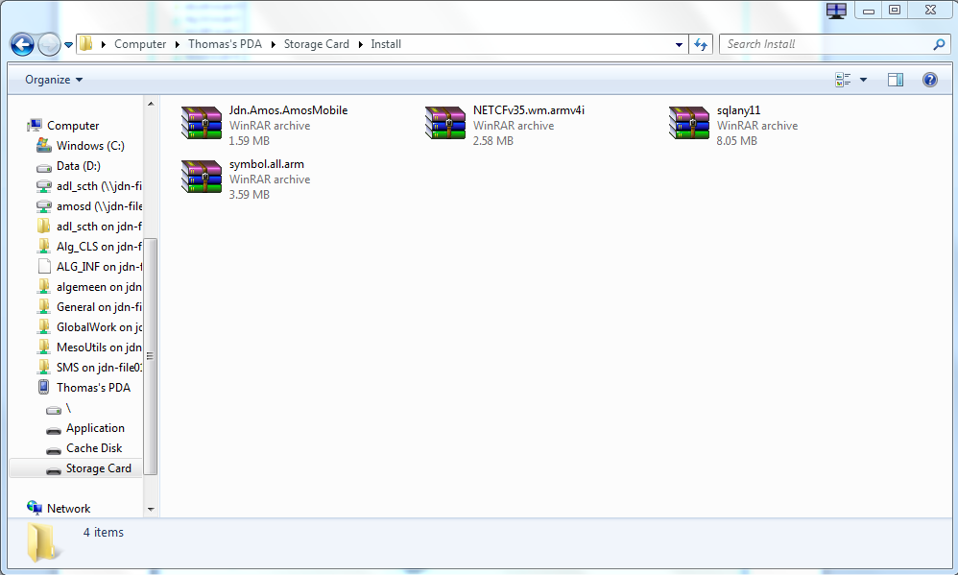

# Installation on mobile device

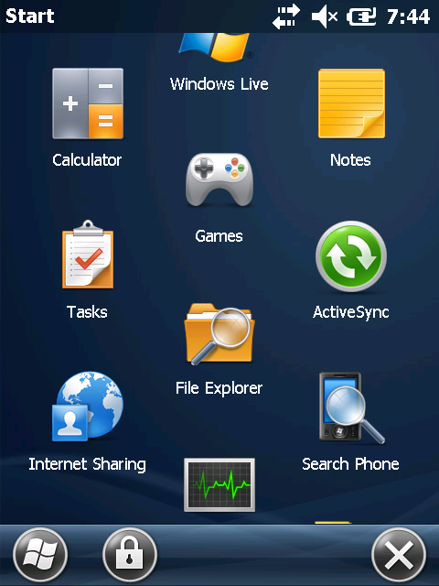

* Go to the main menu
* Click on “File Explorer”

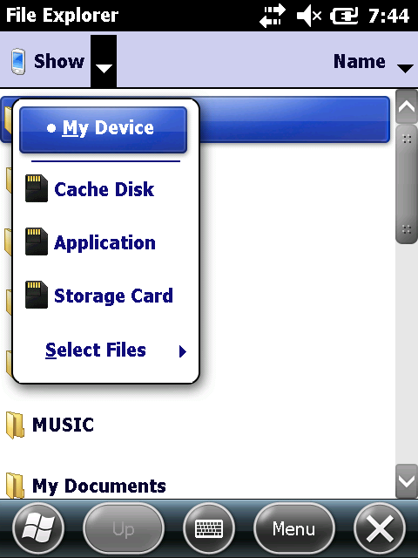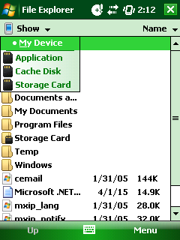

* In the top left corner you should see some a dropdown with a downwards facing arrow next to it. Click on this.
* Click on ‘Storage Card’
* 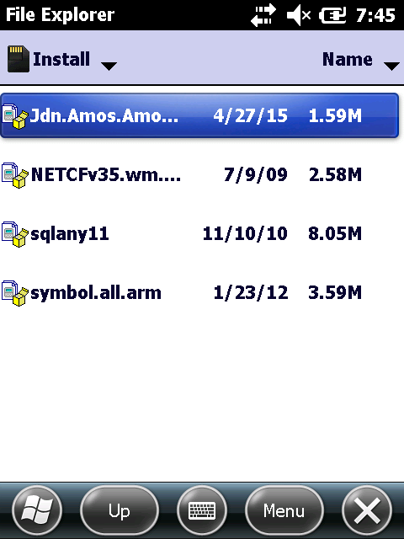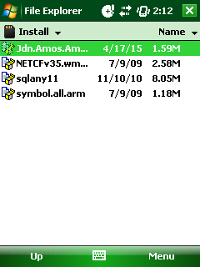Click on the folder ‘Install’
* Install (or re-install) the prerequisites (When asked for the location to install, chose “On Device” for each installer)

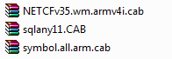

* Install (or re-install) Amos Mobile (When asked for the location to install, chose “\Application”)  
  

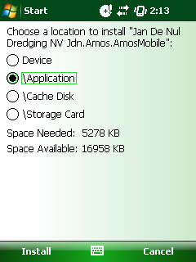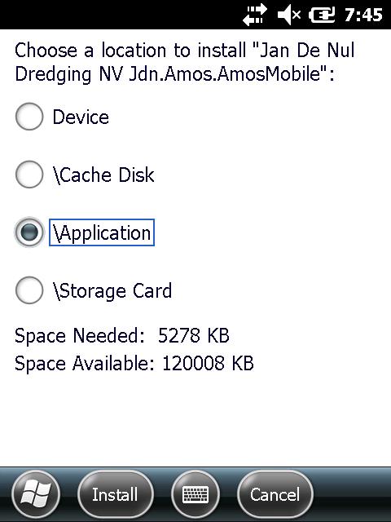

* It might ask to replace the previous version, click on ‘OK’
* Reboot the device (by holding the red power button)